Assignment1: 28, April.

1. Do NLP classification for any text doc , using one of ML rule supervised algorithms (SVM, KNN, NB)

I used the Random Forest model for the classification of tweets sentiments.

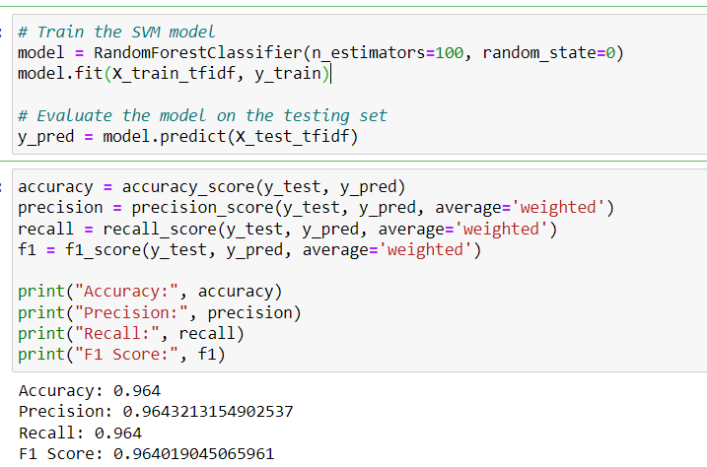

1. Apply POS in classification and explain how POS will change the result.

POS tagging decreased the results of classification as shown below:

1. Does using the morphological analyzer will change the result of classification.

It also deceased the accuracy of the Random Forest.

1. Evaluate the classification using F1, Recall and precision.

1. What is TF-IDF and are you going to apply with the process of classification.

TF-IDF is a technique of calculating the frequency of the token by comparing its existence with other documents or text.

I also used it in the classification process for getting frequency of the word from tweets text.